# **Centennial (VI) 2009-2016**

The Hyundai Centennial (VI) 2009-2016 Air Suspension System has 2 Front Air Struts and 2 Rear Air Spring Bags with 2 Rear Shock Absorbers. Height Sensors tell the Control Module when the Air Suspension Compressor needs to inflate or deflate the Air Suspension System. The Solenoid Valve Block will distribute the Air accordingly throughout the Air Suspension System. Here at Bavaria Center you will find many of the necessary parts and components to fix your Hyundai Centennial (VI) 2009-2016 Air Suspension System for less.

# **Hyundai Centennial Air strut Air Suspension Front Left Side**

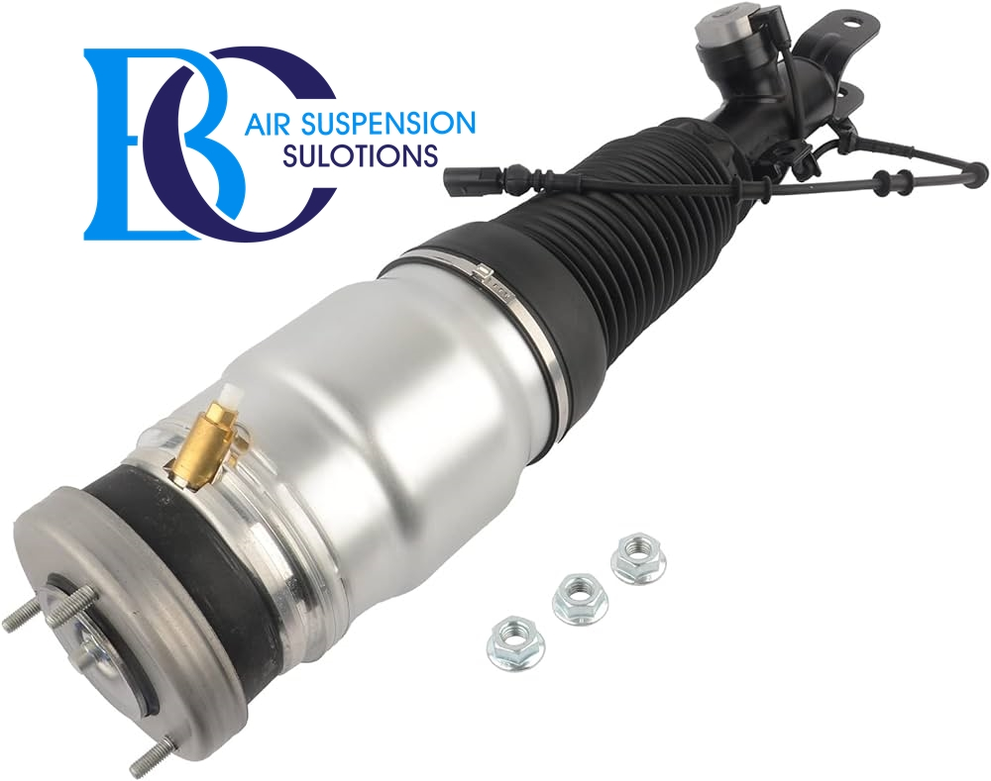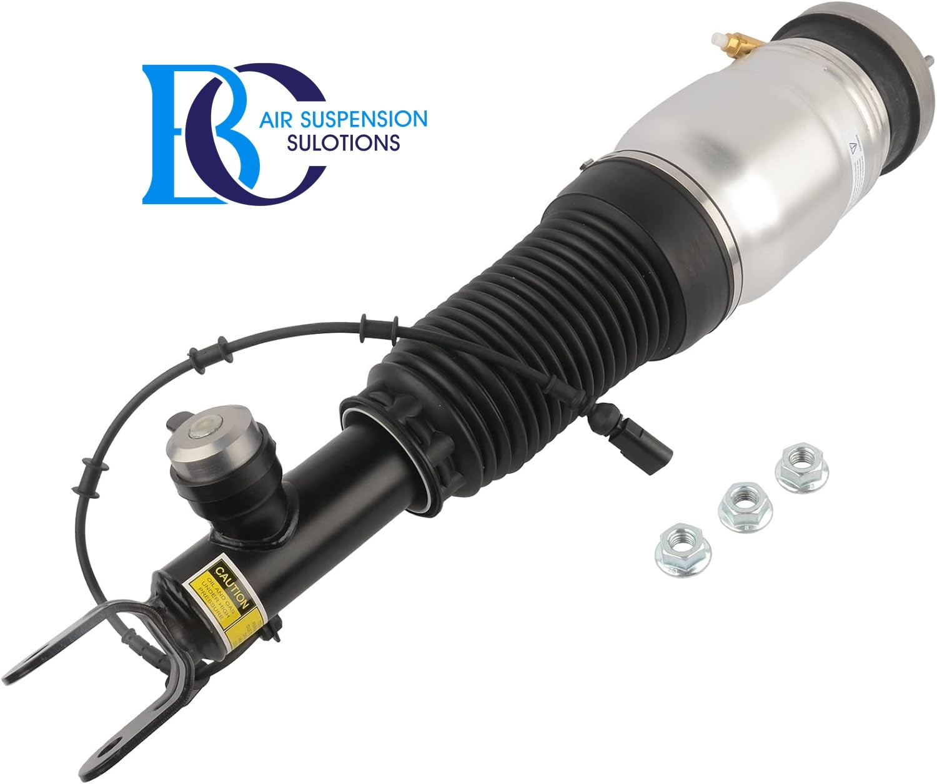

**Description**

This is Hyundai Centennial 2009-2016 front left Air Strut Air Suspension.

**It can be installed in the following vehicles:**

Hyundai Equus / Centennial 2009-2016

Hyundai Genesis 2009-2016

**OEM part numbers:**

546053N517

# **Hyundai Centennial Air strut Air Suspension Front Right Side**

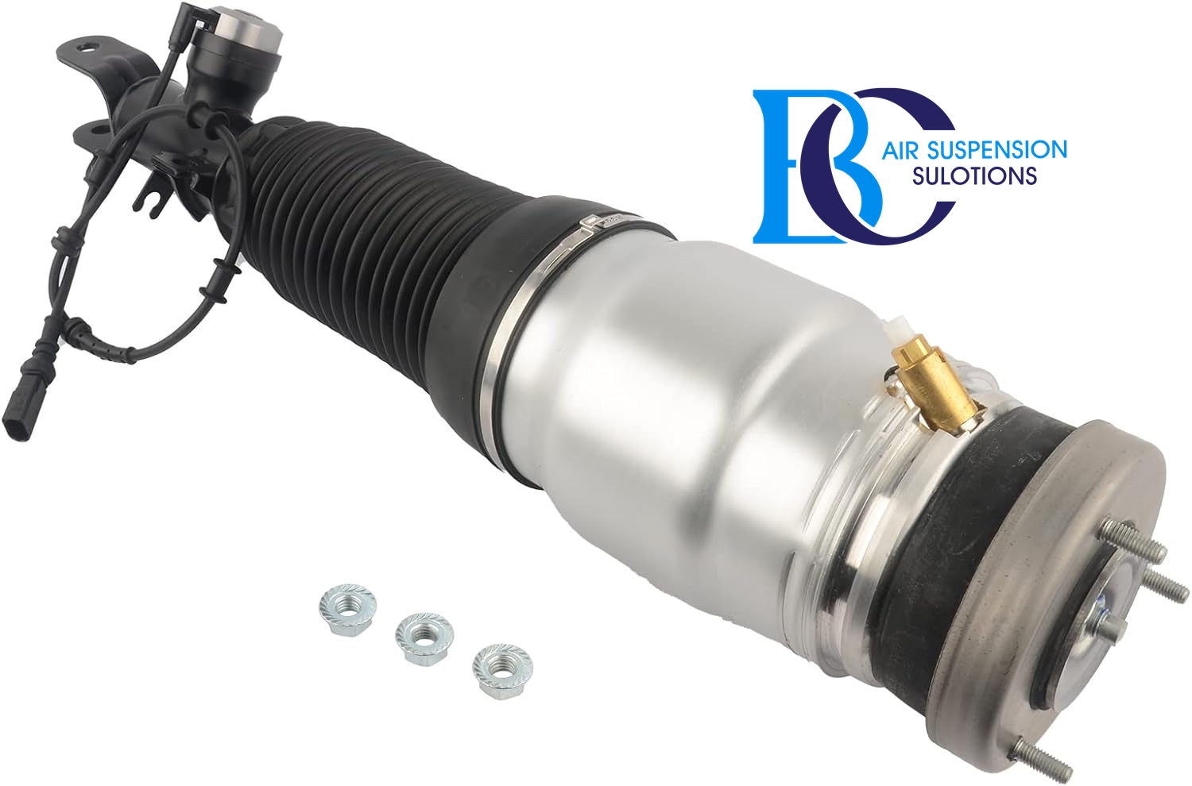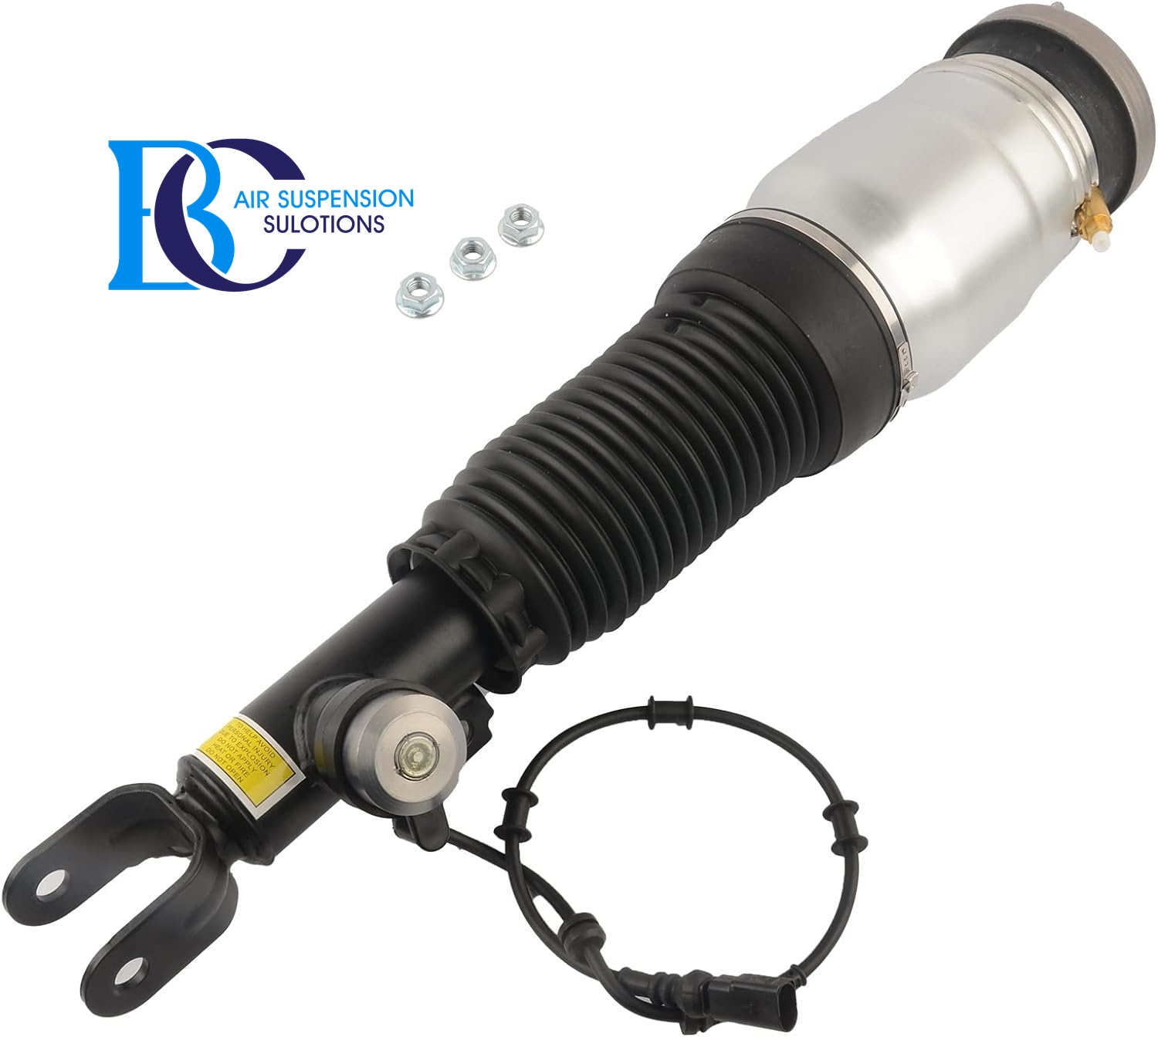

**Description**

This is the Hyundai Centennial 2009-2016 front right Air Strut Air Suspension.

**It can be installed in the following vehicles:**

Hyundai Equus / Centennial 2009-2016

Hyundai Genesis 2009-2016

**OEM part numbers:**

546063N517

# **Hyundai Centennial Air Spring air suspension Rear left**

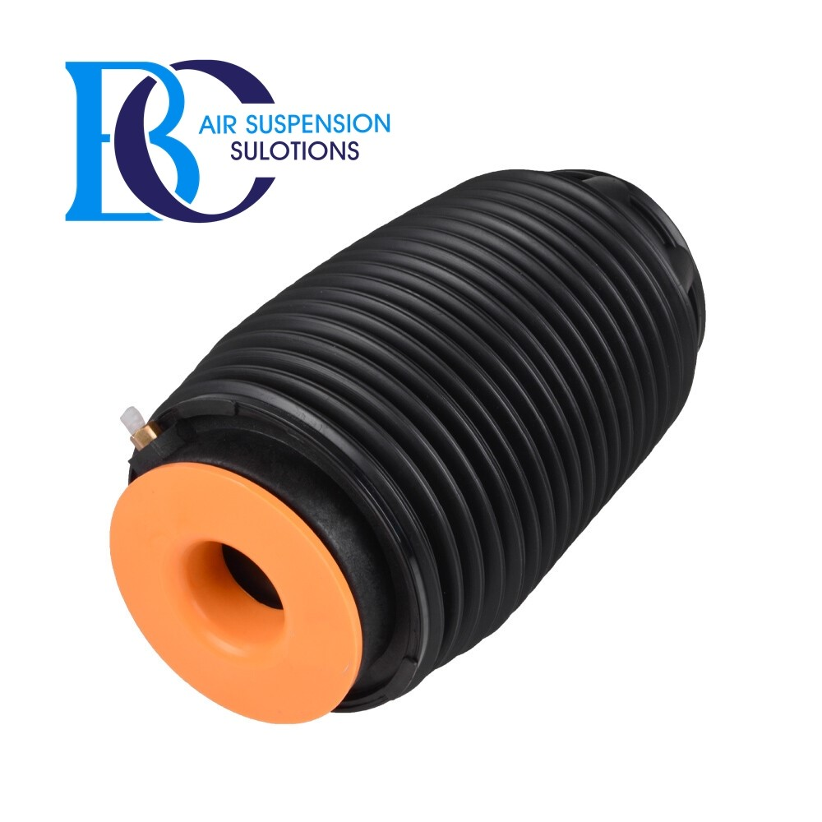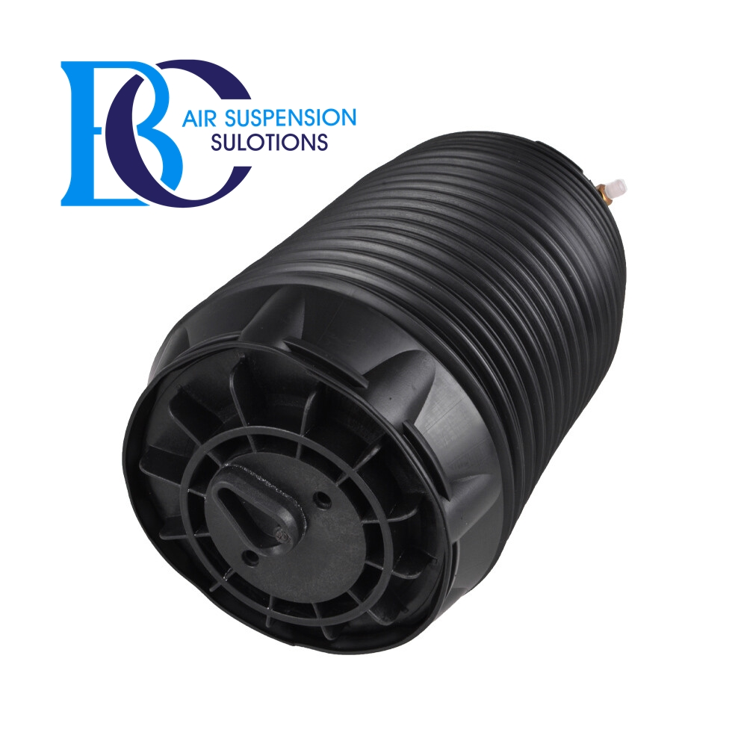

**Description**

This is the Hyundai Centennial Rear left Air Spring.

**It can be installed in the following vehicles:**

Hyundai Equus / Centennial 2009-2016

Hyundai Genesis 2009-2016

**OEM part numbers:**

553503M501

# **Hyundai Centennial Air Spring air suspension Rear Right**

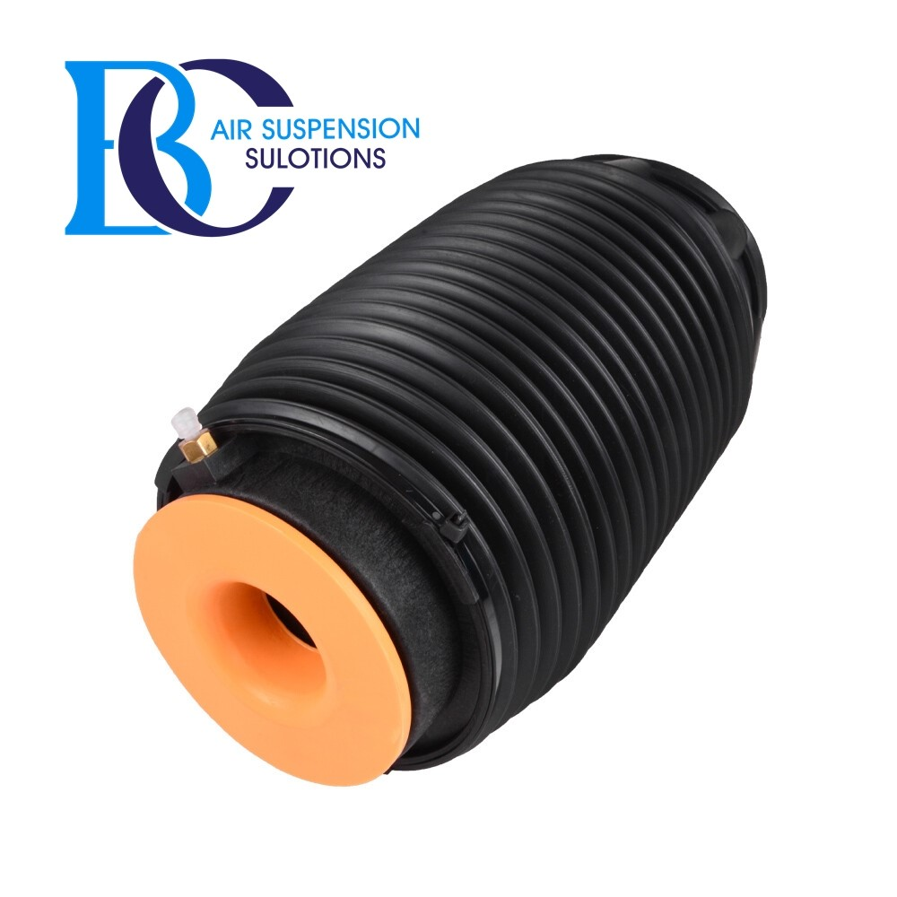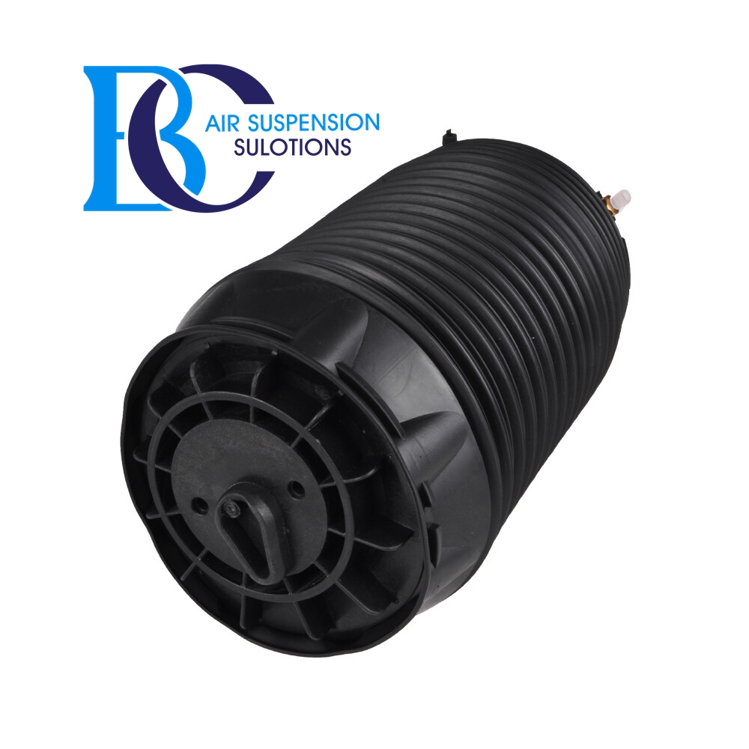

**Description**

This is the Hyundai Centennial Rear Right Air Spring.

**It can be installed in the following vehicles:**

Hyundai Equus / Centennial 2009-2016

Hyundai Genesis 2009-2016

**OEM part numbers:**

553603M501

# **Hyundai Centennial Compressor air suspension**

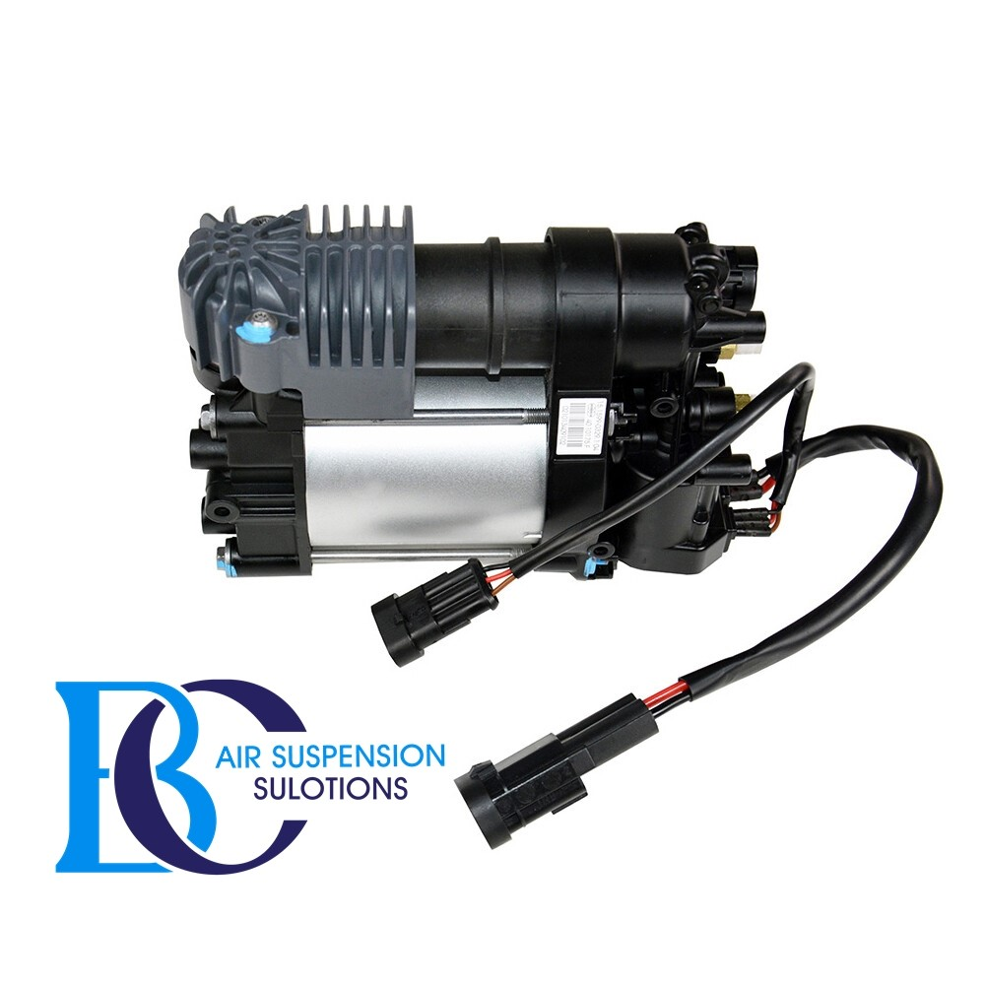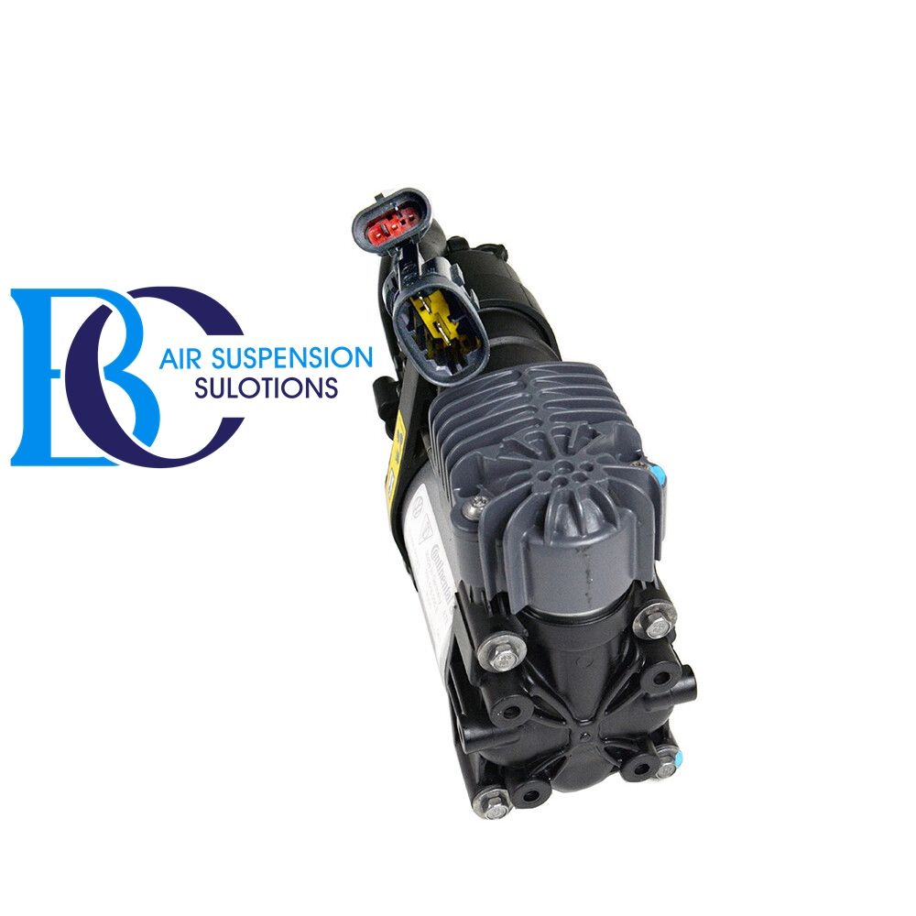

**Description**

This is the air compressor for the air suspension of the Hyundai Genesis.

**Can be installed in the following vehicles:**

Hyundai Equus / Centennial (2009 -2016)

Hyundai Genesis 2009-2016

**OEM part number:**

558103M000

# **Hyundai Centennial Valve unit air suspension**

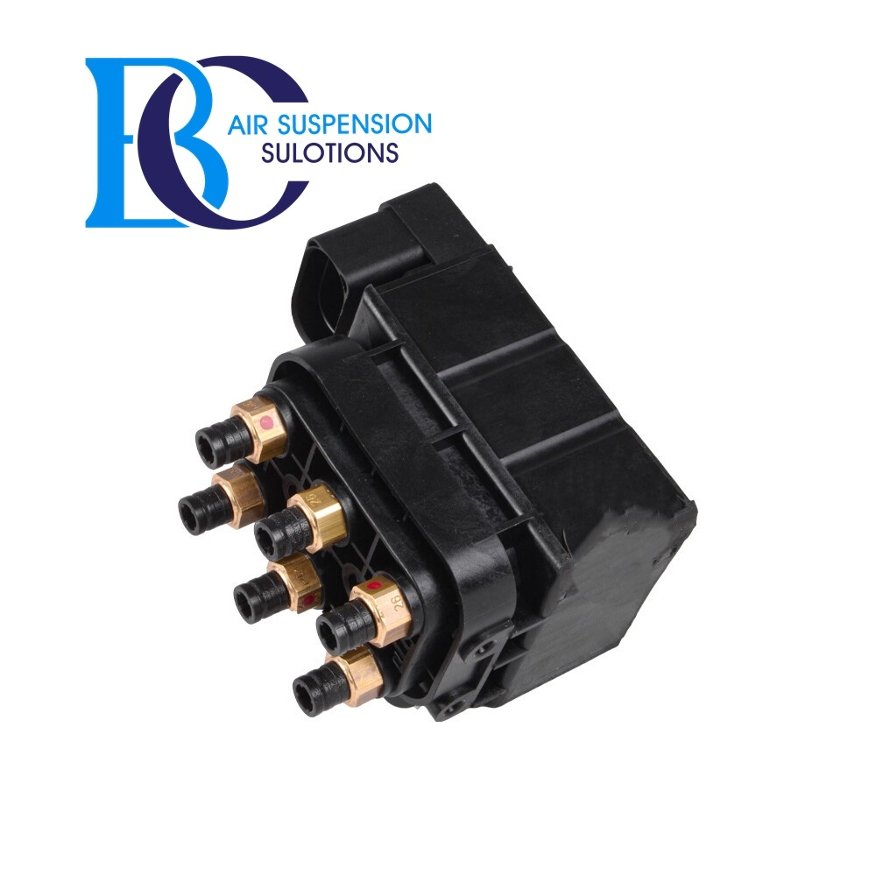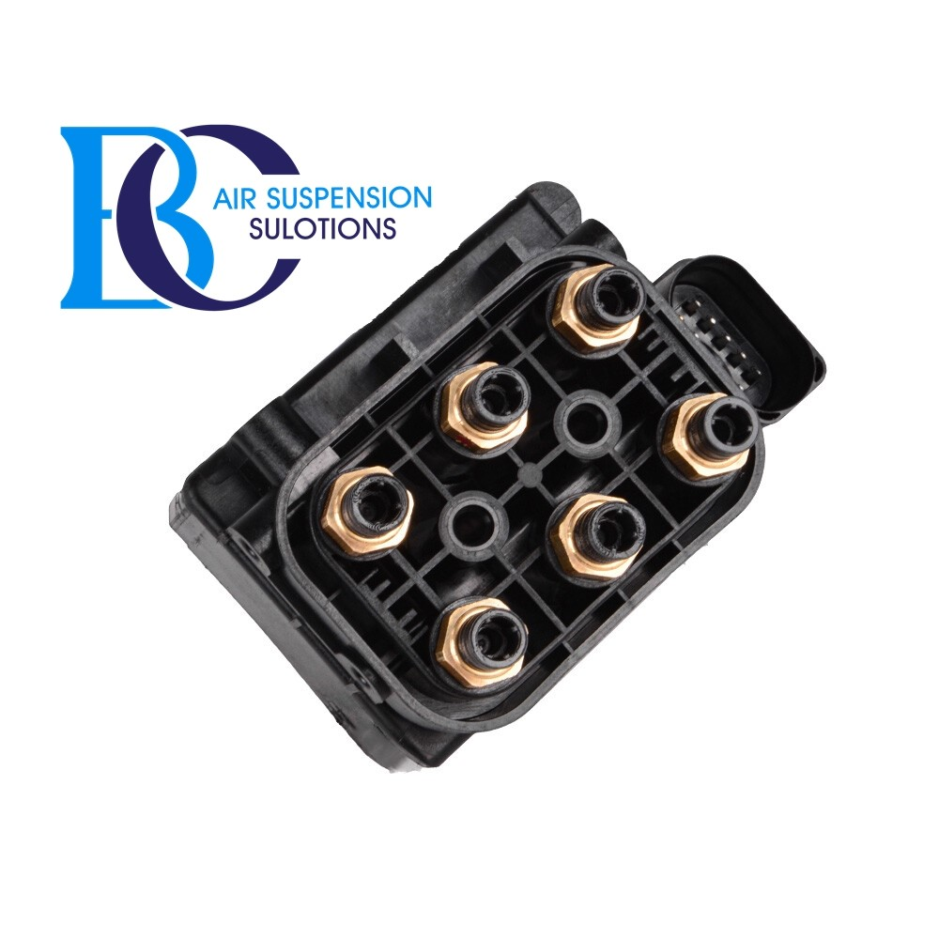

**Description**

This is the control valve for the air suspension of the Hyundai Genesis Equus.

**Can be installed in the following vehicles:**

Hyundai Equus / Centennial 2009-2016

Hyundai Genesis 2009-2016

**OEM part numbers:**

558103M000